Fertility rate and Life expectancy Dashboard Question2
Q. Which country in Europe had the highest fertility rate for its continent in 1980, but gradually changed to have the lowest fertility rate.?
Answer: Poland
- In 1980: Poland had highest fertility rate:
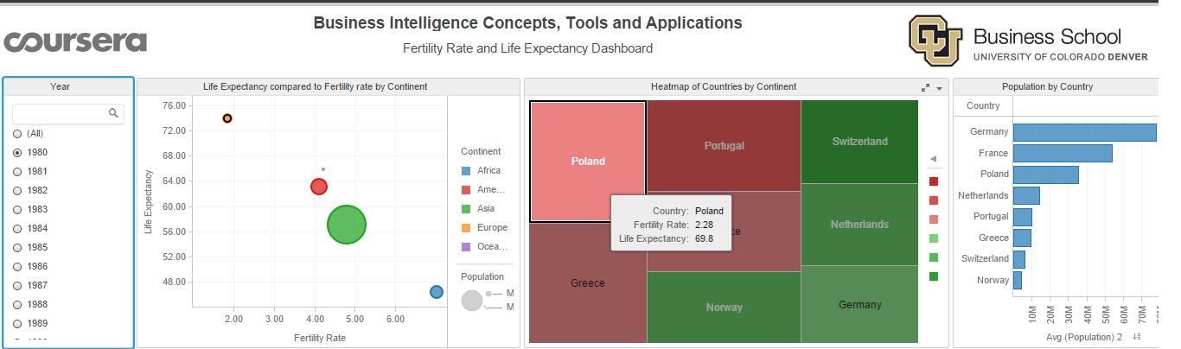
- In 2007: Poland has lowest fertility rate:
